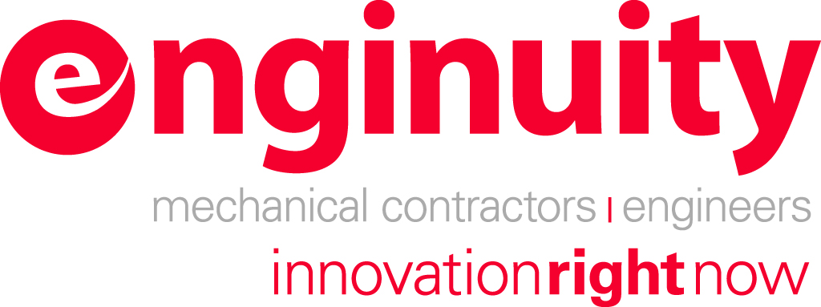


News Release FOR IMMEDIATE RELEASE Contact: DeAnna Halewski
(717) 652-0100, ext. 21
DHalewski@sacunas.net

Central Penn Business Journal Honors Region's Top 50 Fastest Growing Companies

Harrisburg, PA (September 23, 2008) - The Central Penn Business Journal announced and honored the top fifty businesses that have made significant contributions to the growth, strength and success of the Central PA region during the 12th annual Top 50 Fastest Growing Companies awards breakfast at Hilton Harrisburg on Friday, September 19, 2008. Enginuity LLC is proud to announce its rank of number 11 on this year's list. This marks the third year in a row that Enginuity has been ranked among this prestigious group.
During the Top 50 Fastest Growing Companies awards breakfast, the ranking of the fifty winning companies was announced. Emcee for the event was David A. Schankweiler, publisher of the Central Penn Business Journal. The breakfast and awards ceremony featured guest speaker Steve Zuckerman, President and CEO of Clipper Magazine.
In order to be eligible for nomination, companies needed to show revenue of at least $500,000 in each of the fiscal years ending 2005, 2006 & 2007 and show revenue growth in 2007, as compared to 2005 (a three-year period). Eligible companies had to be for-profit entities headquartered in Cumberland, Dauphin, Lancaster, Lebanon, Perry or York County.
Presenting sponsor, SF & Company, calculated the nominations and then ranked the companies according to revenue growth over the three-year period. Both dollar and percentage increases were taken into consideration. This ranking formula led to the recognition of the 2008 Top 50 Fastest Growing Companies, consisting of both large and small companies.
In addition to the awards breakfast on September 19, the Top 50 Fastest Growing Companies are profiled in a special supplement to the October 3 issue of the Central Penn Business Journal. The complete list of honorees is published in ranked order, along with information on each company's financial growth.
The Top 50 Fastest Growing Companies event is a program of the Central Penn Business Journal and is presented by SF & Company. Citizens Bank, Highmark Blue Shield, JPL, PennVenture Partners, CORL Communications and The Wireless Authority are sponsors of the event.

